Problem statement1: Find the top five kinds of Google Knowledge Occupation people who were guests in the show, in a particular time period. Take the time period as 1/11/99 to 6/11/99 i.e., 6 months

Solution:

Program of find the top five kinds of google knowledge occupation

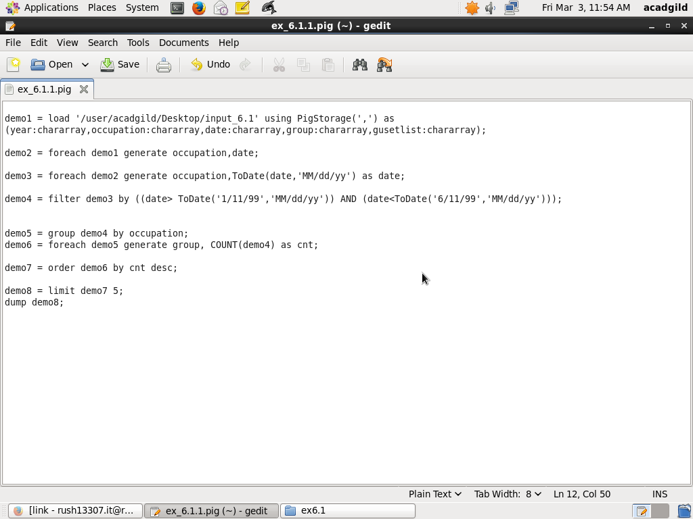

Output :

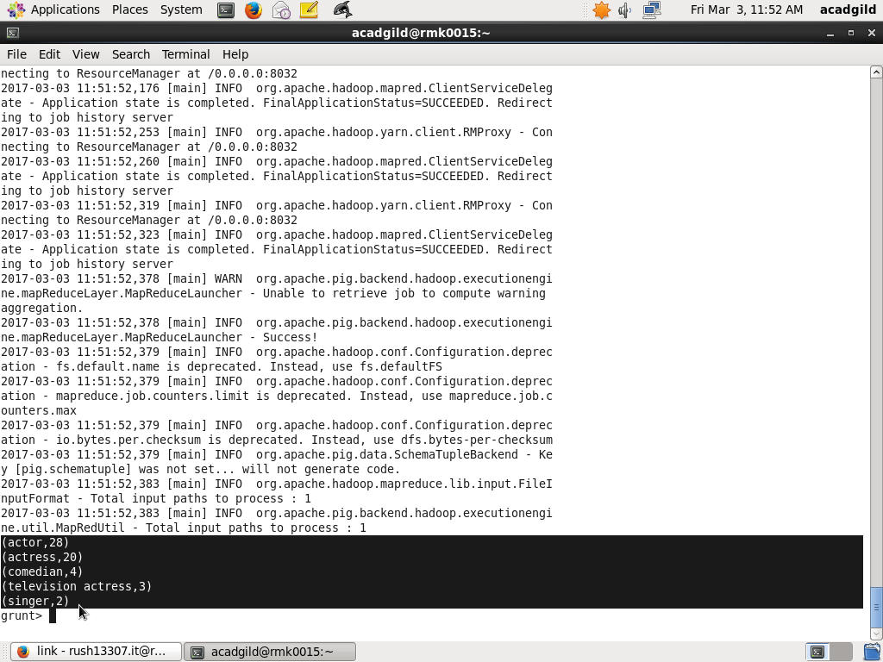

Problem statement2: Find the number of Google Knowledge occupation types in each group, who have been guests on the show

Solution

Program to find the number of google knowledge occupation types in each group who are guests

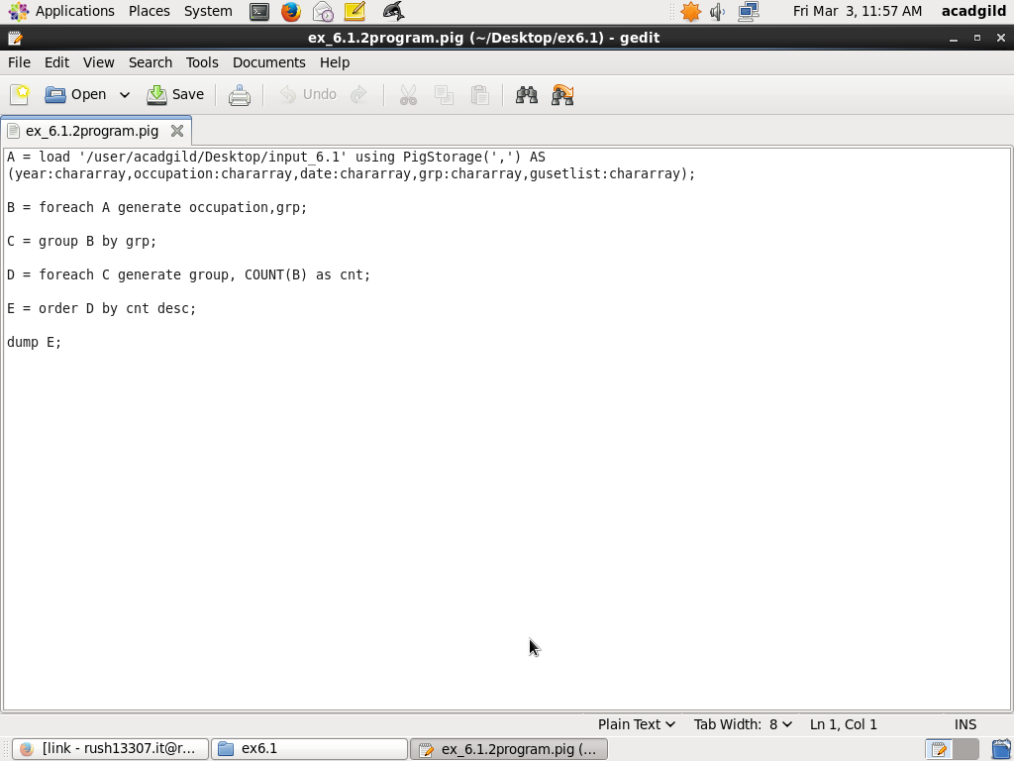

Output:

